JOB DESCRIPTION

JOB DETAILS
Post title: | IT Support Technician
Post grade: | D
Directorate: | Transformation
Section: | Digital Services
Reporting to: | First Line Support Manager
Line manager: | No
Date updated: | August 2025
MAIN PURPOSE OF JOB
Support the council’s service desk operation. Provide the first point of contact and first line support, delivering excellent customer service via telephone, ITSM and face to face user enquiries and requests.

Diagnose issues and log all enquiries, provide first time fixes to common service issues, assign more complex issues to appropriate support staff and external partners.

Represent excellence in service delivery, performance and technical ability. Consistently deliver at the highest level of customer service, productivity and technical proficiency.
SPECIFIC DUTIES
- As first point of contact for service desk customers, answer common queries, diagnose and resolve a wide variety of 1st line common and in-depth technical issues, including desktop support, supported systems, products and services.
- Assign more complex issues to other technical teams and partners. Where required, work with team leaders or management for escalations and speedy resolutions.
- Provide the highest level of customer service experience, meeting the needs of general users, chief officers and members.
- Log all enquiries and provide first-time fixes to common service issues, resolving problems independently wherever possible.
- Log, manage, update and resolve user incidents and requests within agreed SLAs, ensuring appropriate categorisation and priority level, exceeding standard quality control and productivity targets. Document incidents and requests accurately, recording all relevant information, ensuring all 1st line diagnostic steps are followed.
- Maintain a high level of knowledge of current council standard hardware and software configurations, operating procedures and advise colleagues and users how to make better use of the council’s services and systems.
- Support the rest of the team in problem resolution, using creative problem-solving, collaborative behaviour and a pragmatic approach.
- Actively develop yourself, seeking out opportunities to seek feedback and learning experiences.
- Maintain a high level of knowledge of the Council’s support and security policies and actively promote and uphold these, supporting service desk agents in this area when required.
- Undertake all duties with due regard to the provisions of health and safety regulations and legislation, Data Protection/GDPR, the Council’s Equal Opportunities and Customer Care policies.
- Perform all duties in line with Council’s staff values showing commitment to improving residents lives and opportunities, demonstrating respect and fairness, taking ownership, working towards doing things better and working together across the council
ORGANISATIONAL CHART
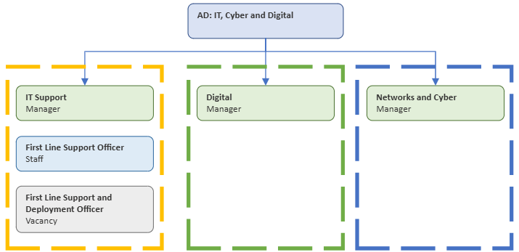

KEY WORKING RELATIONSHIPS
The postholder will be working with members of staff at all levels of the organisation, elected members and third parties.

RESOURCES
Responsible for the safekeeping of ICT equipment issued for use as part of the role.
Record keeping and inventory of assets.
Procurement of peripheral items such as headsets, mice and keyboards.

PHYSICAL DEMANDS
Office based working with some physical demands moving/handling ICT equipment.
Running cabling around and under desks.
Sitting at a desk for prolonged period of time

MENTAL DEMANDS
This post is responsible for ensuring that the day to day effective running of the ICT support system. This will involve empathy with the demands of the council’s staff and members.
Ability to manage potentially multiple operational issues and problems. The post holder must be willing and able to deal with the frustrations of users and be able to analyse the data input into the ICT support system. They will also need to recommend changes to improve the delivery of ICT services and training.

WORKING ENVIRONMENT
The postholder will be expected to work 100% from the Tewkesbury offices. This may develop into least three days per week and may work the remainder from home if their home environment is in compliance with the remote working policy.
May be required to work at alternative sites as part of the role.

ALL STAFF RESPONSIBILITIES
To adhere to all Council Policies, in particular Equal Opportunities.

To undertake any other duties properly assigned from time to time by your line manager which are appropriate to the grade and character of the post.

To be committed to the principles of equality, diversity and the ability to treat everyone who you come in contact with dignity and respect.

Tewkesbury Borough Council is committed to the principles of safeguarding and promoting the welfare of all children, young people and vulnerable adults; therefore, all employees have a responsibility and duty of care to report safeguarding issues they become aware of or witness.

HEALTH AND SAFETY
Ensuring that services are delivered in compliance with existing and new Health and Safety legislation and the Council’s Health and Safety Policy and ensuring that duties are pursued in a safe manner with due regard to the Health and Safety of yourself and others.

PERSON SPECIFICATION
QUALIFICATIONS |  | ESSENTIAL | DESIRABLE | ASSESSMENT METHOD
Minimum 5 GCSE’s (or equivalent, e.g. O’Level, NVQ Level 2) |  | ☒ | ☐ | Application
NVQ Level 3 qualification or equivalent e.g. 2 ‘A’ levels or BTEC award or certificate or diploma in a relevant field |  | ☐ | ☒ | Application
Vocational or professional qualifications in a relevant discipline |  | ☐ | ☒ | Application
ITIL Foundation qualification |  | ☐ | ☒ | Application
EXPERIENCE |  | ESSENTIAL | DESIRABLE | ASSESSMENT METHOD
Experience of providing ICT support in a busy corporate environment and to remote workers |  | ☒ | ☐ | Application/Interview
Experience using ICT support desk software |  | ☒ | ☐ | Application/Interview
Experience of supporting and resolving queries about MS Office or Office 365, Windows 11 |  | ☒ | ☐ | Application/Interview
Experience of working with external suppliers to resolve technical problems |  | ☒ | ☐ | Application/Interview
Experience of deploying new technology such as laptops and mobile phones |  | ☒ | ☐ | Application/Interview
Public sector experience |  | ☐ | ☒ | Application/Interview
SKILLS |  | ESSENTIAL | DESIRABLE | ASSESSMENT METHOD
Windows Server, Windows Desktop, Office 365 support skills |  | ☐ | ☐ | Application/Interview
A basic technical knowledge of using Microsoft Windows Server 2016/2019/2022 including Active Directory |  | ☐ | ☐ | Application/Interview
Basic understanding of installation, support and troubleshooting networks – both local and wide area based |  | ☒ | ☐ | Application/Interview
Use of deployment tools to image computers |  | ☐ | ☒ | Application/Interview
Use of mobile device management tools to deploy and control mobile devices |  | ☐ | ☒ | Application/Interview
Problem solving skills |  | ☒ | ☐ | Application/Interview
Ability to meet deadlines |  | ☒ | ☐ | Application/Interview
Ability to prioritise |  | ☒ | ☐ | Application/Interview
Attention to detail |  | ☒ | ☐ | Application/Interview
BEHAVIOURS / ATTRIBUTES |  | ESSENTIAL | DESIRABLE | ASSESSMENT METHOD
Customer focused |  | ☒ | ☐ | Application/Interview
Supports users with varying IT capabilities |  | ☒ | ☐ | Application/Interview
Open to change and commitment to continuous improvement |  | ☒ | ☐ | Application/Interview
Calm, helpful, co-operative disposition |  | ☒ | ☐ | Application/Interview
Ability to use own initiative |  | ☒ | ☐ | Application/Interview
Strong interpersonal and client liaison skills |  | ☒ | ☐ | Application/Interview
Methodical approach to work |  | ☒ | ☐ | Application/Interview
Ability to work within a team as well as independently |  | ☒ | ☐ | Application/Interview

